<https://leetcode.com/discuss/interview-question/549310/JP-morgan-interview>

<https://leetcode.com/problems/predict-the-winner/>

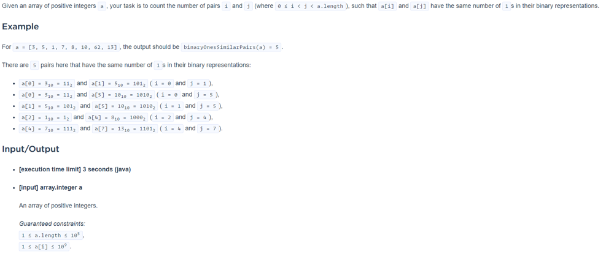

There are N cities and M roads, and the cities are connected to other cities by those roads, Terrorists have planted bombs in every city. Each bomb will explode one after other(First bomb in City 1 then city 2 and so on)  
Each explosion will destroy the city and the roads which are connected to it.  
For each explosion, you need to return the number of connected components of cities.

Input format->  
N M  
A1 B1  
A2 B2....

Constraints->  
1<=N<=2 \* 1e5  
0<=M<=min(2 \* 1e5,N\*(N-1)/2))

Output format -> array

Example->

Input->

6 7

1 2

1 4

1 5

2 4

2 3

3 5

3 6

Output->

1

2

3

2

1

0

Do the problem in a reverse manner suppose all the cities are destroyed as of now so the current number of components is zero. Now build that city and make a connection to every other city having a value greater than the current city if the connection was present in the originally given graph.  
If while connecting two cities we find that they were from different components decrease the number of components by 1 and unite them using DSU.  
Finally, increase the number of components by one because one component also got included because of the current city while making all of its connections.

Connected component: A group of vertices that are connected by edges in a way that there is a path between any two pairs of vertices in the group. (i.e. a tree that may have cycles (backwards edges))

Q1: Find the sum of distance between consecutive numbers, numbers are non-repetitive and can be in any random order. (Index distance in the array)

Q2: Sort the list of Integers with minimum number of swaps. In addition, sort it in a way that even numbers are at the start of list in ascending order and the odd numbers are at the end of list in descending order.

